Contents of the Contract: Exemption Clauses and Unfair Terms

Dr Can Eken

Scope of the Lecture
This lecture will cover the law related to exclusion and limitation clauses in contracts. By the end of this lecture you should be able to understand what an exemption clause is, whether it has been properly incorporated into the contract, and whether there are any common law rules of interpretation to determine its effect and/or whether there is a statute that impacts on the effectiveness of the clause.

Preparatory Readings

Compulsory Readings
Depending on your choice of textbook, you must read the section on exclusion clauses e.g.,
- Janeth O’Sullivan, O’Sullivan & Hilliard’s The Law of Contract, (10th ed, OUP 2022) – Chapter 8
- Mindy Chen-Wishart, Contract Law (7th ed, OUP 2022) Chapter 11.

Key Cases
(Note that you should be engaging in reading more cases than those listed here – but these are highlighted as some of the crucial cases in this area). You do not need to read these cases in advance of the lecture.

- Hollier v Rambler Motors [1972] 2 QB 721
- Transocean Drilling UK Ltd v Providence Resources Ltd [2016] EWCA Civ 372

- Canada Steamships Lines Ltd v The King [1952] AC 394
- HIH Casualty and General Insurance Ltd v Chase Manhattan Bank [2003] UKHL 6

- George Mitchell (Chesterhall) Ltd v Finney Lock Seeds Ltd [1983] 2 AC 803
- Watford Electronics Ltd v Sanderson CFL Ltd [2001] EWCA Civ 317
- GoodLife Foods Ltd v Hall Fire Protection Ltd [2018] EWCA Civ 1371

- Director General of Fair Trading v First National Bank plc [2002] 1 AC 481
- ParkingEyeLtd v Beavis [2015] UKSC 67

Optional Readings
These are academic texts and commentaries that you may find useful in developing your understanding. It is not compulsory to read these items, but it is recommended that you do so in preparation for your exam, though you do not need to look at these in advance of the lecture.

- Susan Bright, ‘Winning the battle against unfair contract terms,’ (2006) 20 Legal Studies 331
- Roger Brownsword and John Adams, ‘The Unfair Contract Terms Act: A Decade of Discretion,’ (1988) 104 Law Quarterly Review 94

What are Exemption Clauses?

Exclusion clauses are those in which one of the parties to the contract attempt to exclude liability for breach of contract or a breach of an obligation in tort law, OR they seek to exclude certain remedies.

Limitation clauses are those in which of the parties to the contract attempts to limit (as opposed to entirely exclude) their liability for breach of contract or a breach of an obligation in torts OR the limit the remedy available.

The common law surrounding these clauses focuses on:

- Is there a clause that purports to restrict / exclude liability for loss suffered by one party? [Is it a term?]

- Has the clause been properly incorporated into the contract? [Application of the common law principles related to all terms: signature, notice, timing, previous course of dealings]

- What is the effect of the clause? [Application of the common law principles of interpretation: literal approach, purposive approach]

There is also an additional question for consideration:

- Is there are statute that impacts on the clause’s effectiveness?

Interpreting Exclusion / Limitation Clauses

Contra proferentem rule
- Ambiguities are generally resolved against the part who drafted or proposed the wording

Hollier v Rambler Motors [1972] 2 QB 71, per Lord Justice Salmon
“Fires can occur from a large variety of causes, only one of which is negligence on the part of the occupier of the premises, and that is by no means the most frequent cause… To my mind, if the defendants were seeking to exclude their responsibility for a fire caused by their own negligence, they ought to have done so in far plainer language than the language used here.”

Hut Group Ltd v Nobahar-Cookson [2016] EWCA Civ 128, per Lord Justice Briggs
“Ambiguity in an exclusion clause may have to be resolved by a narrow construction because an exclusion clause cuts down or detracts from the ambit of some important obligation in a contract, or a remedy conferred by the general law such as (in the present case) an obligation to give effect to a contractual warranty by paying compensation for breach of it. The parties are not lightly to be taken to have intended to cut down the remedies which the law provides for breach of important contractual obligations without using clear words having that effect.”

Transocean Drilling UK Ltd v Providence Resources Ltd [2016] EWCA Civ 372

Alisa Craig Shipping Co Ltd v Malvern Fishing Co Ltd [1983] 1 WL 458

Consumer Rights Act 2015, s. 69 (1)
‘if a term in a consumer contract, or a consumer notice, could have different meanings, the meaning that is most favourable to the consumer is to prevail.’

Excluding liability for negligence

Canada Steamships Lines Ltd v The King [1952] AC 394

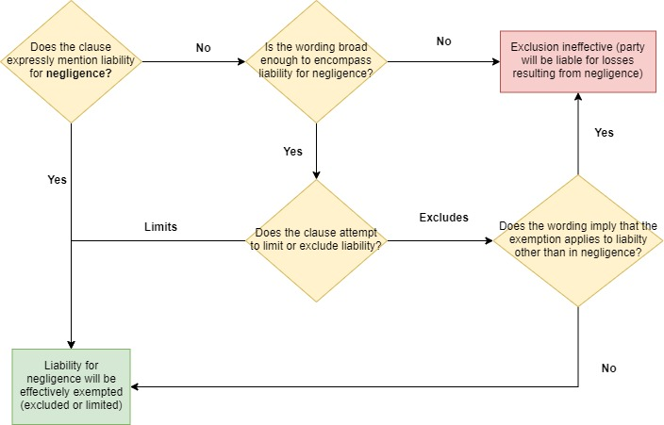

HIH Casualty and General Insurance Ltd v Chase Manhattan Bank [2003] UKHL 6, per Lord Hoffman
“The question, as it seems to me, is whether the language used by the parties construed in the context of the whole instrument and against the admissible background, leads to the conclusion that they must have thought it went without saying that the words already literally wide enough to cover negligence, did not do so.”

Statutory Controls on Unfair Terms

Which Statute is Applicable?
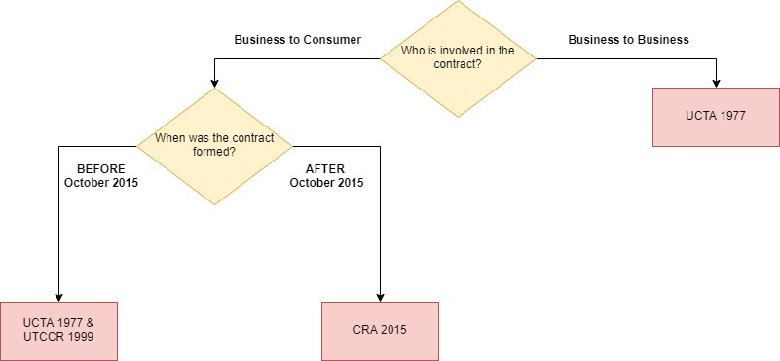

The Statutes

Unfair Contract Terms Act 1977

- Is the Statute applicable?

S.1 (3) ‘In the case of both contract law and tort, sections 2 to 7 apply… only to business liability, that is liability for breach of obligations or duties arising –

(a) from things done or to be done by a person in the course of a business (whether his business or another’s); or
(b) from the occupation of premises used for business purposes of the occupier.

- Negligence Liability under UCTA

S.1 (1) ‘Negligence means the breach –
(a) of any obligation, arising from the express or implied terms of a contract, to take reasonable care or exercise reasonable skill in the performance of the contract;
(b) of any common law duty to take reasonable care or exercise reasonable skill (but not any stricter duty)….’

s. 2 (1) ‘A person cannot by reference to any contract term or to a notice given to persons generally or to particular persons exclude or restrict his liability for death or personal injury resulting from negligence.

(2) In the case of other loss or damage, a person cannot so exclude or restrict his liability for negligence except in so far as the term or notice satisfies the requirement of reasonableness.

(3) Where a contract term or notice purports to exclude or restrict liability for negligence a person’s agreement to or awareness of it is not of itself to be taken as indicating his voluntary acceptance of any risk.

Phillips Products Ltd v Hyland [1987] 1 WLR 659
Thompson v T Lohan (Plant Hire) Ltd [1987] 1 WLR 649

- Standard Terms under UCTA

S.3 (1) ‘This section applies as between contracting parties where one of them deals... on the other’s written standard terms of business.
(2) As against that party, the other cannot by reference to any contract term—
(a) when himself in breach of contract, exclude or restrict any liability of his in respect of the breach; or
(b) claim to be entitled—
(i) to render a contractual performance substantially different from that which was reasonably expected of him, or;
(ii) in respect of the whole or any part of his contractual obligation, to render no performance at all, except in so far as (in any of the cases mentioned above in this subsection) the contract term satisfies the requirement of reasonableness.’

Chester Grosvenor Hotel v Alfred McApline (1992) 56 Build LR 115, per Justice Stannard
“[Terms] should be so regarded by the party which advances them… [who] should habitually contract in those terms. If it contracts also on other terms, it must be determined… whether this has occurred so frequently that the terms in question cannot be regarded as standard, and if on any occasion a party has substantially modified its prepared terms, it is a question of fact whether those terms have been so altered that they must be regarded as not having been employed on that occasion.”

- Anti-Avoidance Provisions

S.13 (1) ‘To the extent that this Part of this Act prevents the exclusion or restriction of any liability it also prevents—
(a) making the liability or its enforcement subject to restrictive or onerous conditions;
(b) excluding or restricting any right or remedy in respect of the liability, or subjecting a person to any prejudice in consequence of his pursuing any such right or remedy;
(c) excluding or restricting rules of evidence or procedure’

Stewart Gill Ltd v Horatio Myer & Co Ltd (1992) QB 600

The Reasonableness Test
S. 11 (1) ‘In relation to a contract term, the requirement of reasonableness for the purposes of this Part of this Act… is that the term shall have been a fair and reasonable one to be included having regard to the circumstances which were, or ought reasonably to have been, known to or in the contemplation of the parties when the contract was made.’

George Mitchell (Chesterhall) Ltd v Finney Lock Seeds Ltd [1983] 2 AC 803

Watford Electronics Ltd v Sanderson CFL Ltd [2001] EWCA Civ 317, per Lord Justice Chadwick
“Where experienced businessmen representing substantial companies of equal bargaining power negotiate an agreement, they may be taken to have had regard to the matters known to them. They should, in my view, be taken to be the best judge of the commercial fairness of the agreement which they have made, including the fairness of each of the terms of that agreement… Unless satisfied that one party has, in effect, taken unfair advantage of the other – or that a term is so unreasonable that it cannot properly have been understood or considered – the court should not interfere.”

GoodLife Foods Ltd v Hall Fire Protection Ltd [2018] EWCA Civ 1371, per Lord Justice Coulson
“The terms freely agreed by commercial parties are of primary importance, particularly where, as here, the parties are of broadly equal size and bargaining power and the appellant could have engaged an alternative supplier on different terms.”

Consumer Rights Act 2015

- Is the Statute Applicable?

S.62 (1) ‘This Part [Part 2 of the Act governing unfair terms] applies to a contract between a trader and a consumer.’

S.2 (2) ‘”Trader” means a person acting for purposes relating to that person’s trade, business, craft or profession…’

S.2 (3) ‘”Consumer” means an individual acting for purposes that are wholly or mainly outside the individual’s trade, business, craft or profession.”

- Negligence Liability under the CRA 2015

S.65 (1) ‘A trader cannot by a term of a consumer contract or by a consumer notice exclude or restrict liability for death or personal injury resulting from negligence.
(2) Where a term of a consumer contract, or a consumer notice, purports to exclude or restrict a trader’s liability for negligence, a person is not to be taken to have voluntarily accepted any risk merely because the person agreed to or knew about the term or notice.
(3) In this section “personal injury” includes any disease and any impairment of physical or mental condition.
(4) In this section “negligence” means the breach of—
(a) any obligation to take reasonable care or exercise reasonable skill in the performance of a contract where the obligation arises from an express or implied term of the contract,
(b) a common law duty to take reasonable care or exercise reasonable skill,
(c) the common duty of care imposed by the Occupiers’ Liability Act 1957 or the Occupiers’ Liability Act (Northern Ireland) 1957, or…’

The Fairness Test

S.62 (1) ‘An unfair term of a consumer contract is not binding on the consumer.’

S.62 (4) ‘A term is unfair if, contrary to the requirement of good faith, it causes a significant imbalance in the parties’ rights and obligations under the contract to the detriment of the consumer.

(5) Whether a term is fair is to be determined—
(a) taking into account the nature of the subject matter of the contract, and;
(b) by reference to all the circumstances existing when the term was agreed and to all of the other terms of the contract or of any other contract on which it depends.’

Director General of Fair Trading v First National Bank plc [2002] 1 AC 481
Aziz v Caixa d’Estalvis de Catalunya I Manresa [2013] Case C-26/13, 14 March 2013
ParkingEyeLtd v Beavis [2015] UKSC 67

In principle, any term in a consumer contract can be assessed for fairness. NB: s.31; s.47 and s.57

S.64 (1) ‘A term of a consumer contract may not be assessed for fairness under section 62 to the extent that—
(a) it specifies the main subject matter of the contract, or;
(b) the assessment is of the appropriateness of the price payable under the contract by comparison with the goods, digital content or services supplied under it.

(2) Subsection (1) excludes a term from an assessment under section 62 only if it is transparent and prominent.

(3) A term is transparent for the purposes of this Part if it is expressed in plain and intelligible language and (in the case of a written term) is legible.

(4) A term is prominent for the purposes of this section if it is brought to the consumer’s attention in such a way that an average consumer would be aware of the term.’

Director General of Fair Trading v First National Bank plc [2002] 1 AC 481

